Name: Truc Ho Nguyen

NetID: thv20002

Section: 8

VM IP Address: 172.16.49.54

1. To find the answer for Question 1, I used the MobaSSHTunnel to set up a tunnel to the Husky Banking website. Then I logged in to the user (Sheron54) with the information found in the Q1login file to find my balance (2164).

2. To find the answer for Question 2, I wrote Q2.py on my local machine to attempt a login with every password in Q2dictionary.txt until it found the correct one (eagles69).

3. For Question 3, I used Flask to create a webpage that displays our team number and team names. Then, I showed a TA to receive my approval code (DGJ2BD).

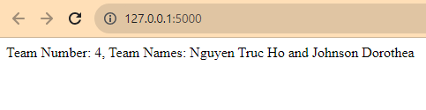

4. For Question 4, I used Flask to clone the Husky Banking webpage by copying its html code and images. If a successful login was performed to this fake webpage, it would write the login information to Q4_managementpage.txt, then redirect the victim to login to the real Husky Banking site. Then, I showed a TA to receive my approval code (SKWUZ9).

5. For Question 5, I used Flask to clone the Husky Banking custom page by copying its html code and using Inspect to download as well as viewing the source code to find the image urls ([Background/goat.jpg](http://localhost:2223/static/images//Background/goat.jpg) and [Blob/lookinAtYA.jpg](http://localhost:2223/static/images//Blob/lookinAtYA.jpg) and Icon/derp.ico). Then, I showed a TA to receive my approval code (E7RJDY).

6. For Question 6, I added some Javascript code to my html file which recorded the inputs and sent them to my Flask code if they were alphanumeric or an underscore. The Flask code immediately wrote the inputs to my Q6_managementpage.txt file. Then, I showed a TA to receive my approval code (3Q0NPC).